Uworld Biology   
  
Immunology   
1) Pathogen binds to B lymphocyte receptor. Is endocytosed (brought inside in pieces) and presented to major histocompatibility class II (MHC II) proteins that bind the antigen pieces.   
  
2) MHC-antigen complexes are transported to the cell surface of the B lymphocyte and integrate into the cell membrane, allowing antigen fragments to be displayed outside the cell and presented to helper T cells bind foreign antigen and release cytokines that inactivate the B lymphocyte.  
  
3) Activated B lymphocytes divides into many clones that differentiate into short lived plasma cells or long lived memory cells.   
  
Natural killer and cytotoxic T cells respond to antigens by releasing toxins that induce apoptosis in nearby infected cells.   
  
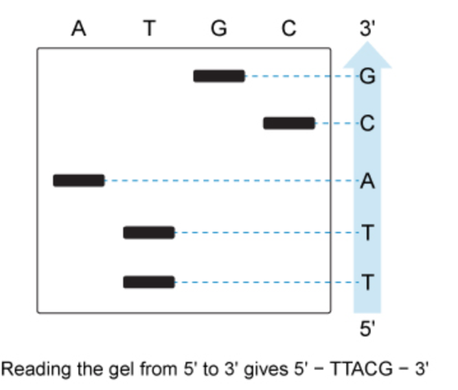  
  
Kidneys function to excrete waste and maintain appropriate solute and water concentrations throughout the body. Nephrons are the functional units of the kidney that filter blood and selectively secrete or reabsorb the contents of the resulting filtrate.   
  
kidneys are anatomically divided into an outer cortex and an inner “salty” renal medulla (inner part of the kidney, containing medullary collecting ducts, loops of Henle, vasa recta, and interstitium). In the renal cortex, glomerular capillaries filter blood into the Bowman’s capsule of the nephron. The filtrate then moves through the proximal tubule and flows into the loop of Henle that reabsorbs water and salt (NaCl).   
  
Countercurrent multiplication forms a concentration gradient within the loop of Henle that maximizes water reabsorption.   
  
1) the descending limb, extending from the cortex into the salty medulla is highly permeable to water but impermeable to NaCl. The filtrate becomes more concentrated as water is passively reabsorbed by osmosis into the medulla where it is taken up by blood vessels.   
  
2) the ascending limb travels from the loop’s lowest point in the medulla back toward the cortex and is impermeable to water but permeable to NaCL. NaCl is first passively reabsorbed into the medulla as the filtrate travels up the ascending limb. As the limb nears the cortex, NaCL is actively transported out of the filtrate and into the medulla, maintaining the medulla’s high salt concentration while facilitating continued water reabsorption in the descending limb.   
  
Q5: in human muscles, Ca2+ plays an important role in skeletal muscle fiber contraction. Sarcoplasmic reticulum is specialized endoplasmic reticulum in muscle fiber that regulates intracellular calcium concentration by sequestering calcium ions during periods of relaxing and releases Ca2+ into the cytosol during contraction periods (responding to action potentials).   
  
cytosolic Ca2+ drives muscle contraction by first binding to troponin, which then allows actin and myosin filaments of the sarcomere to slide across one another.   
  
In another context: in the nervous system at the neuromuscular junction, the entry of calcium ions into presynaptic neurons leads to the release of Ach from the presynaptic vesicles and into the synaptic cleft, where Ach then binds is receptor on the muscle fiber membrane.   
  
Neuromuscular junction (NMJ)   
interface between a somatic motor neuron and a skeletal muscle fiber.   
activity at the NMJ begins on the presynaptic side.   
  
1) The arrival of an action potential at the axon terminal of the presynaptic motor neuron trigger and eventually releases Ach from presynaptic vesicles and into the synaptic cleft via exocytosis.   
  
2) Ach diffuses across the synaptic cleft to bind nicotinic Ach receptors (nAChRs) embedded within the membrane of the postsynaptic muscle fiber, eventually leading to muscle contraction.   
  
3) unbound Ach may diffuse away from the synapse or be degraded by the enzyme acetylcholinesterase (AChE) terminating muscle fiber contraction.   
  
